Q.1 Find and print all divisors of a given natural number n.

**Solution:  
Main Class:**package com.company;  
  
public class Main  
{  
  
 public static void main(String[] args)  
 {  
 Divisor obj = new Divisor();  
 obj.Finddivisor();  
 }  
}

**Divisor Class:** package com.company;  
import java.util.Scanner;  
public class Divisor  
{  
 public void Finddivisor()  
 {  
 int i;  
 System.*out*.print("Enter num : ");  
 Scanner input = new Scanner(System.*in*);  
 int a = input.nextInt();  
 for (i=1;i<=a;i++)  
 {  
 double b = a % i;  
 if(b == 0)  
 {  
 System.*out*.println("The divisor is : " + i);  
  
 }  
  
  
  
 }  
 }  
  
}

**Output:**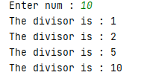

Q.2 Find and print all prime divisors of a given natural number n.  
  
**Solution:  
Main Class:**package com.company;  
import java.util.Scanner;  
public class Main  
{  
  
 public static void main(String[] args)  
 {  
 Primedivisors obj=new Primedivisors();  
 Scanner input=new Scanner(System.*in*);  
 System.*out*.print("Enter a Number : " );  
 int no =input.nextInt();  
 obj.Divisor(no);  
 }  
  
}

**Prime Divisor Class:**package com.company;  
  
public class Primedivisors  
{  
 public void Divisor(int a)  
 {  
 if (a>0)  
 {  
 System.*out*.println(1);  
 for (int i = 2; i <= a; i++)  
 {  
 if (a%i == 0 )  
 {  
 a/=i;  
 System.*out*.println(i);  
 if (a%2==0)  
 {  
 a /= 2;  
 }  
 }  
 }  
 }  
 }  
  
}

**Output:**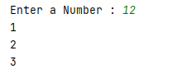

Q.3 Find sum of an infinite row for a given x

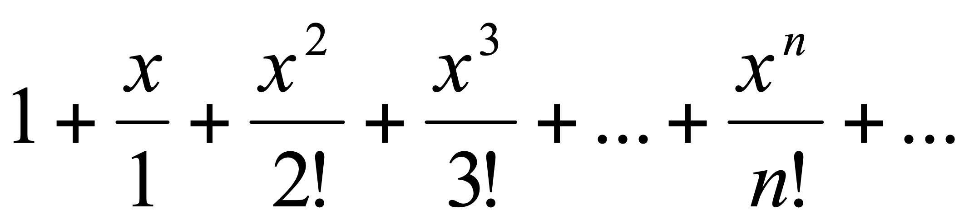

Compare result with a Math.exp(x) method value   
  
  
**Solution:  
Main Class:**package com.company;  
import java.util.Scanner;  
public class Main  
{  
  
 public static void main(String[] args)  
 {  
 Scanner input = new Scanner(System.*in*);  
 System.*out*.print("\nEnter Value of x : ");  
 int x=input.nextInt();  
 System.*out*.print("Enter Value of n : ");  
 int n=input.nextInt();  
 Series obj=new Series();  
 obj.expression(x, n);  
 System.*out*.println("\nMath.exp(x) : " + Math.*exp*(x));  
 }  
}

**Series Class:**package com.company;  
  
public class Series  
{  
 public int fact(int n)  
 {  
 int f=1;  
 for (int i=1;i<=n;i++) {  
 f=i*f;  
 }  
 return f;  
 }  
 public void expression(int x,int n)  
 {  
 double val = 0;  
 for (int i = 0; i <= n; i++) {  
  
 val += Math.*pow*(x, i) / fact(i);  
 }  
 System.*out*.print("Value of series is : " + val);  
 }  
}

**Output:**